Biaozhu.py(已完成标注)
先把你现有 200 条数据按“1/2→类1、3与4且无docstring→类2、4且有docstring与5→类3”的规则统一重标注，然后固定划分一个分层 Test 集，其余数据用分层交叉验证做验证；

Prompt_only_eval.py(需要跑)
接着选 2–3 个可本地部署的代码大模型，用同一套提示词分别在“只输入代码”和“代码+metrics”两种输入形式下跑零样本基线，按 Macro-F1/混淆矩阵选出最优候选；
还未进行
最后只对 Top 模型做 QLoRA/LoRA 微调，再在 Test 集上做一次最终评测，综合性能、推理成本和部署可行性确定最终选型。

你现在应该跑的（大概率跑得动，适合做 prompt-only 基线）

Qwen2.5-Coder-7B-Instruct（主力基线，建议 4-bit）

StarCoder2-7B(-Instruct)（强对照组，建议 4-bit）

Phi-3.5-mini-instruct（3.8B）（轻量快速基线，跑分很快）

（可选补充）Code Llama-7B-Instruct（老牌对照，跑得动但可能不如上面两个 coder 系列）

能力更强但你这台机器上不建议/基本跑不动（尤其要做推理批量评测/后续微调）

StarCoder2-15B

Qwen2.5-Coder-14B / 32B

DeepSeek-Coder-V2-Lite（16B 级）、DeepSeek-Coder-V2 更大版本

Code Llama-13B / 34B

（边界项）Yi-Coder-9B：有时“勉强能推理”，但很吃显存/容易卡；做批量评测和后续微调通常不划算

- 所有的报告,（包含模型的选择）方法的选择很重要。
- 下周给pierre说明模型选择
- 代码的文件，三个部分
- Competence ？个人的报告？
- Pierre更好的电脑或者云端

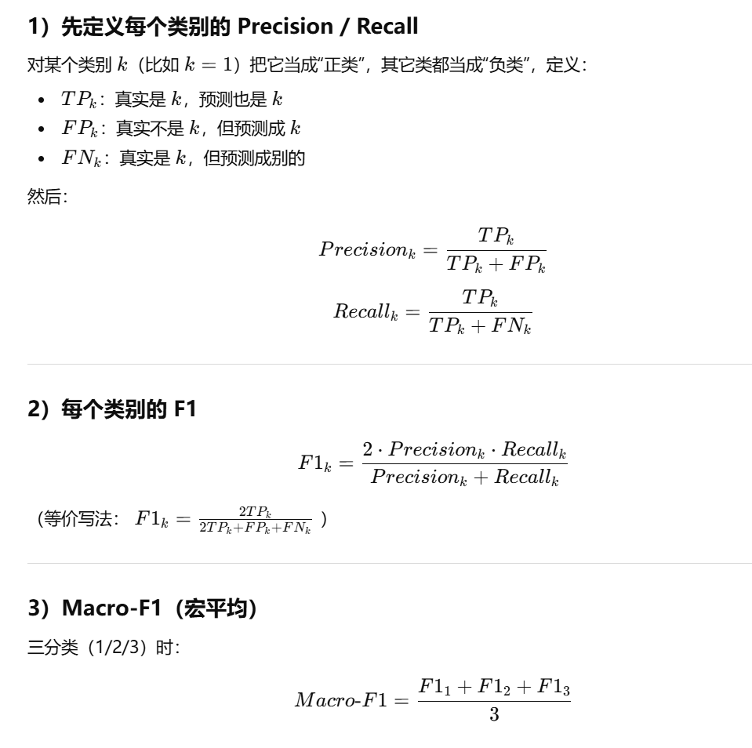

model Qwen/Qwen2.5-Coder-7B-Instruct（val_code.jsonl）
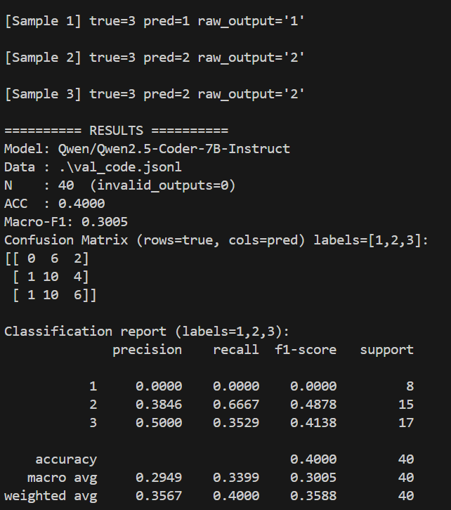
model Qwen/Qwen2.5-Coder-7B-Instruct（val_code_metrics.jsonl）
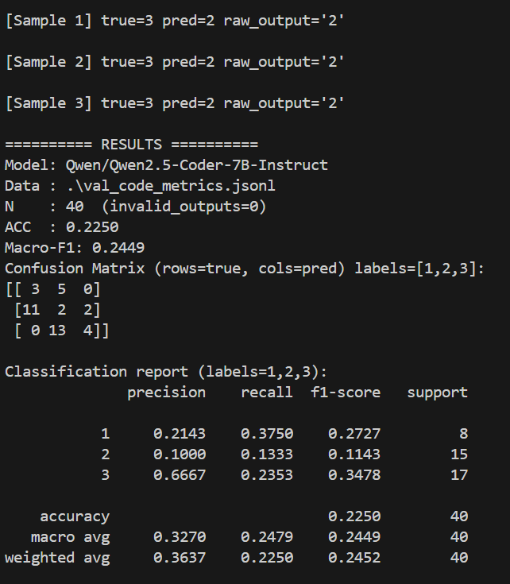

model microsoft/Phi-3.5-mini-instruc（val_code.jsonl）

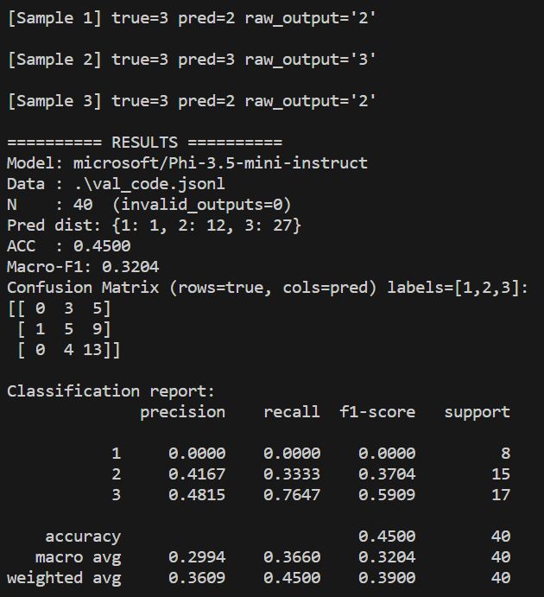

model microsoft/Phi-3.5-mini-instruc（val_code_metrics.jsonl）

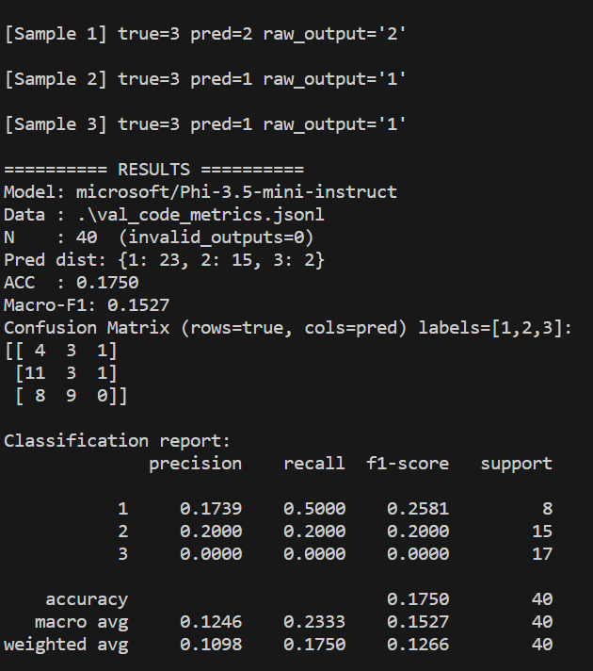
model bigcode/starcoder2-7b（val_code.jsonl）
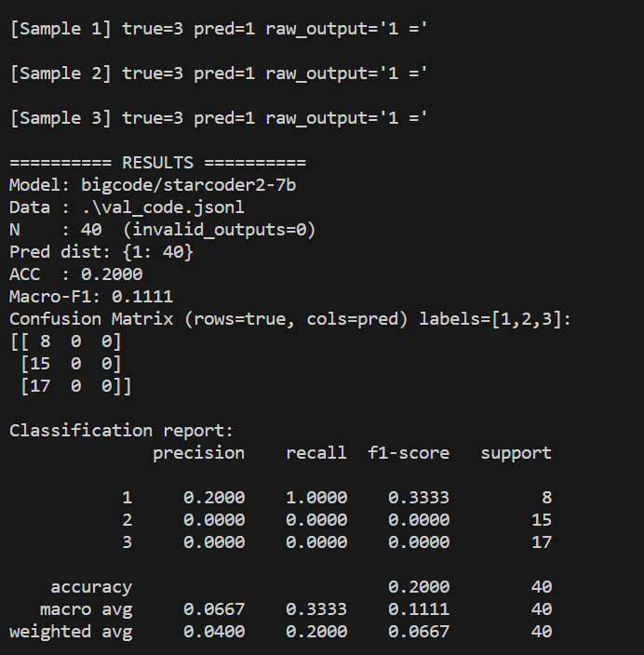

Modelbigcode/starcoder2-7b（val_code_metrics.jsonl）
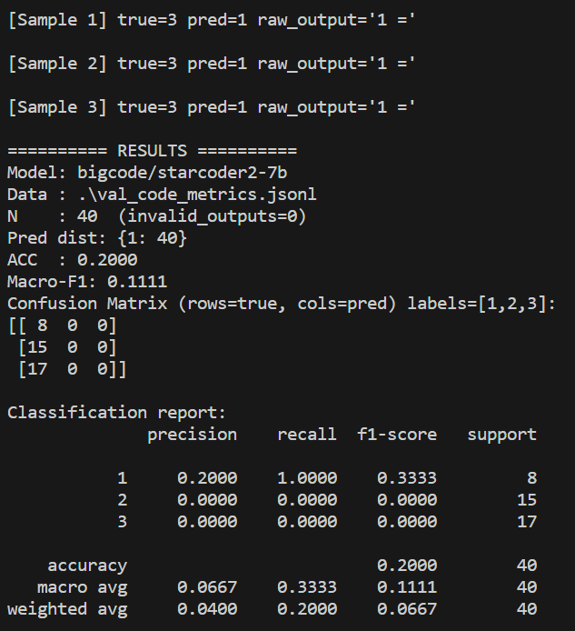
model codellama/CodeLlama-7b-Instruct-hf（val_code.jsonl）

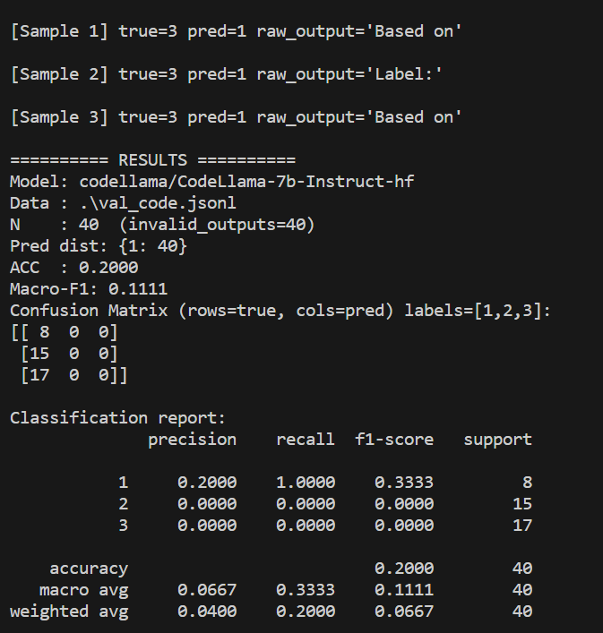
model codellama/CodeLlama-7b-Instruct-hf （val_code_metrics.jsonl）

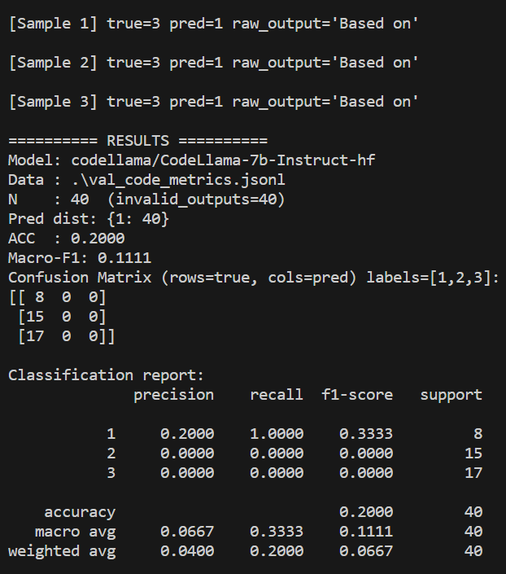

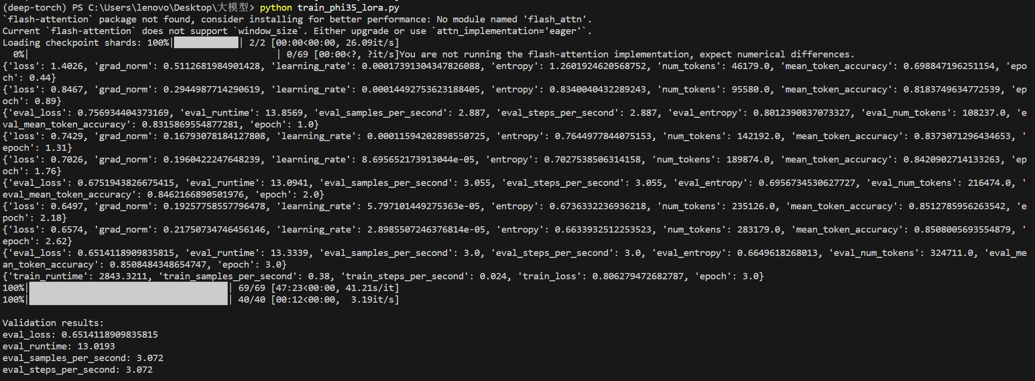
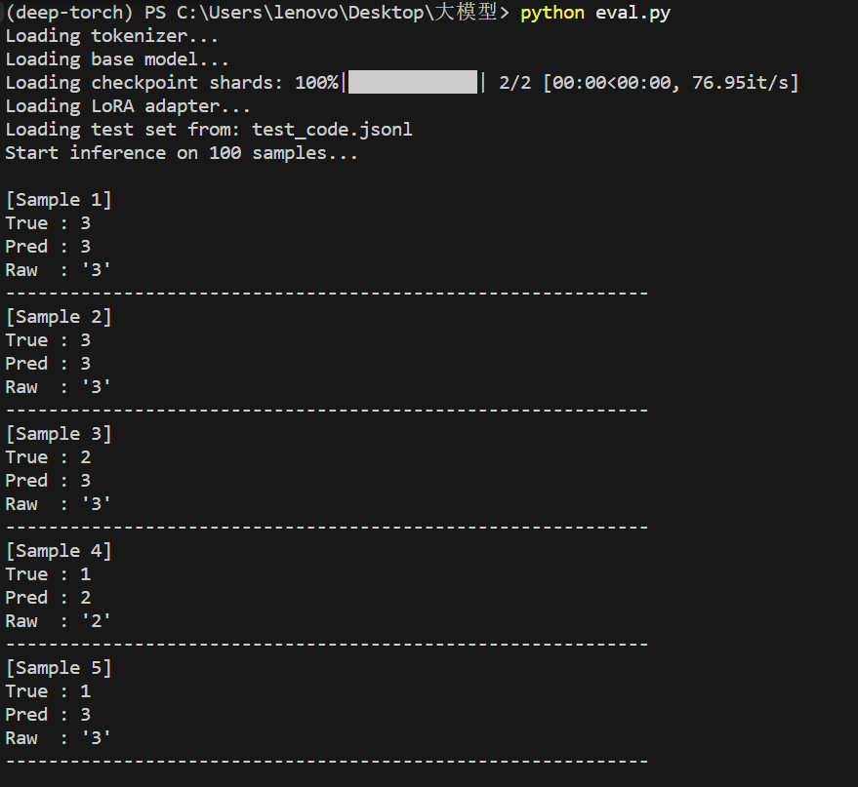
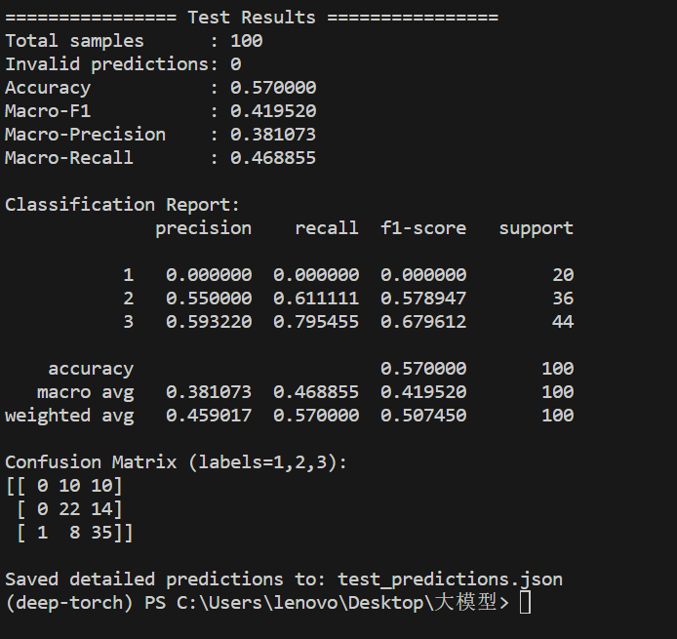
中文：
本次实验完成了一个较为完整的三分类微调与测试流程。我们以 train_code.jsonl 作为训练集、val_code.jsonl 作为验证集，对 microsoft/Phi-3.5-mini-instruct 进行了 LoRA 微调，并在每个 epoch 结束后使用验证集进行评估，再根据验证集上的 eval_loss 自动选择最佳 checkpoint。训练一共进行了 3 个 epoch，最终训练结束时的 train_loss 约为 0.8063，最佳模型对应的 eval_loss 约为 0.6514。这说明模型已经能够在训练集和验证集上学习到一定规律，并且验证损失下降到了一个相对稳定的水平。训练过程中还遇到了一些环境与兼容性问题，例如 flash-attention 提示、显存不足以及测试阶段的 DynamicCache.seen_tokens 报错，但这些问题最终都得到了处理，其中测试阶段通过去掉 trust_remote_code=True 后已能够正常完成推理。
在独立测试集 test_code.jsonl 上，模型最终取得了 Accuracy = 0.5700，Macro-F1 = 0.4195，Macro-Precision = 0.3811，Macro-Recall = 0.4689，测试样本总数为 100，且无无效预测。这说明模型在输出格式上是稳定的，能够按照要求生成合法标签 1/2/3，因此当前结果主要反映的是分类能力本身，而不是输出异常导致的性能下降。从分类报告来看，模型对三类样本的识别能力很不均衡：类别 3 的表现最好，Precision 为 0.5932，Recall 为 0.7955，F1-score 为 0.6796；类别 2 次之，Precision 为 0.5500，Recall 为 0.6111，F1-score 为 0.5789；而类别 1 的 Precision、Recall 和 F1-score 全部为 0。混淆矩阵进一步说明了这一点：20 个真实属于类别 1 的样本中，没有一个被正确预测为 1，其中 10 个被分到类别 2，另外 10 个被分到类别 3；36 个真实属于类别 2 的样本中，有 22 个预测正确，14 个被误分为类别 3；44 个真实属于类别 3 的样本中，有 35 个预测正确，仅有少量被分到类别 2 或类别 1。整体来看，当前模型已经具备了区分中高质量测试用例的能力，尤其对类别 3 的识别效果相对较好，但对于低质量测试用例，也就是类别 1，几乎没有形成有效判别能力，这也是导致 Macro-F1 偏低的最主要原因。
如果从实验意义上来总结，这次结果说明当前的 Phi-3.5 + LoRA 基线方案已经成功跑通，并且在技术流程上是可行的，但分类性能仍有明显提升空间。尤其值得注意的是，模型表现出较强的“偏向预测为 2 或 3”的趋势，这意味着在现有输入形式下，类别 1 的特征还没有被模型充分捕捉。后续如果继续优化，更合理的方向应当是回到验证集上而不是测试集上进行调整，例如进一步改写 instruction，使三类尤其是低质量测试的判别标准更明确；或者尝试 code + metrics 版本，因为类别 1 往往不仅体现在代码文本表面，也可能与 assertion_count、has_docstring、cyclomatic_complexity 等结构性指标有关。总的来说，这次实验已经为后续调参和对比实验提供了一个清晰、可复现的基线。
English:
This experiment successfully completed a full three-class fine-tuning and evaluation pipeline. We used train_code.jsonl as the training set and val_code.jsonl as the validation set to fine-tune microsoft/Phi-3.5-mini-instruct with LoRA. The model was evaluated on the validation set after each epoch, and the best checkpoint was selected automatically based on validation eval_loss. The training ran for 3 epochs in total. At the end of training, the final train_loss was about 0.8063, and the best validation eval_loss was about 0.6514. These values indicate that the model was able to learn meaningful patterns from the training data and reached a relatively stable validation loss. During the process, several environment and compatibility issues were encountered, including flash-attention warnings, CUDA memory limitations, and the DynamicCache.seen_tokens error during testing. These issues were eventually resolved, and in particular, removing trust_remote_code=True fixed the inference-time compatibility problem.
On the held-out test set test_code.jsonl, the model achieved an Accuracy of 0.5700, a Macro-F1 of 0.4195, a Macro-Precision of 0.3811, and a Macro-Recall of 0.4689. The test set contained 100 samples, and there were no invalid predictions. This means that the model was stable in terms of output format and was able to consistently generate valid labels 1, 2, or 3. Therefore, the current performance mainly reflects the classification capability itself rather than formatting failures. Looking at the class-wise results, the performance was highly unbalanced across the three classes. Class 3 achieved the best results, with Precision = 0.5932, Recall = 0.7955, and F1-score = 0.6796. Class 2 performed moderately well, with Precision = 0.5500, Recall = 0.6111, and F1-score = 0.5789. However, Class 1 was not recognized at all, with Precision, Recall, and F1-score all equal to 0. The confusion matrix confirms this pattern: among the 20 true Class 1 samples, none were predicted correctly, with 10 misclassified as Class 2 and 10 as Class 3; among the 36 true Class 2 samples, 22 were correctly classified and 14 were misclassified as Class 3; among the 44 true Class 3 samples, 35 were predicted correctly, with only a few errors toward Class 2 or Class 1. Overall, the model has already learned to distinguish medium- and high-quality test cases to some extent, especially Class 3, but it almost completely fails to identify low-quality test cases, which is the main reason for the relatively low Macro-F1.
From an experimental perspective, these results show that the current Phi-3.5 + LoRA baseline is technically workable and has been successfully executed end-to-end, but there is still significant room for improvement in classification performance. A particularly important observation is that the model shows a strong tendency to predict samples as Class 2 or Class 3, suggesting that the characteristics of Class 1 are not being captured effectively under the current input formulation. If further optimization is carried out, it should be done based on the validation set rather than the test set. Promising directions include refining the instruction so that the distinctions between the three classes, especially the low-quality category, become clearer, and testing the code + metrics setting, since Class 1 may not be fully reflected by the code text alone and may depend more strongly on structural indicators such as assertion_count, has_docstring, or cyclomatic_complexity. In summary, this experiment provides a clear and reproducible baseline for subsequent tuning and comparison studies.
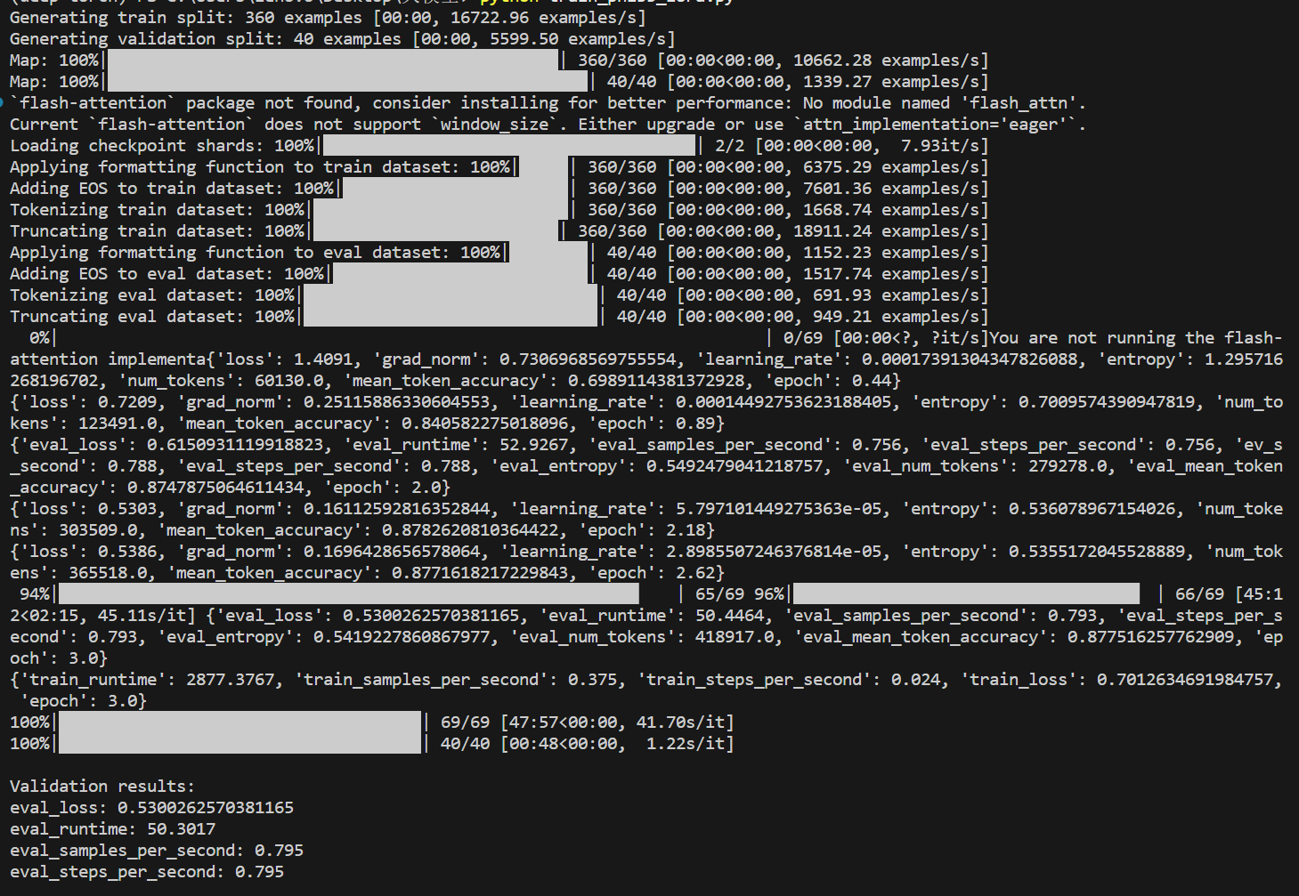
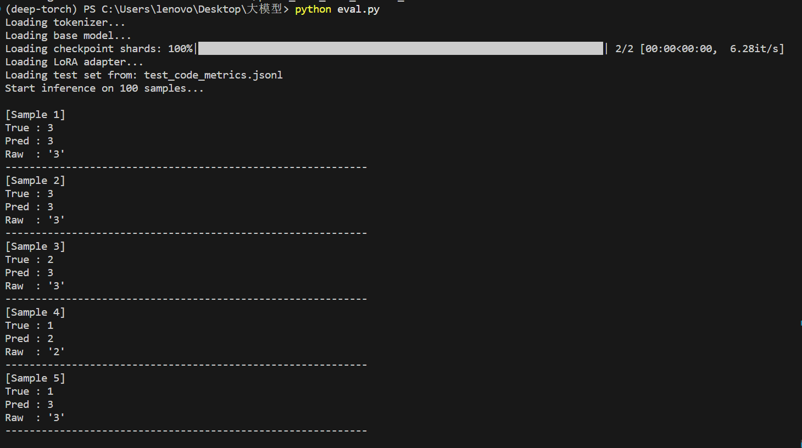
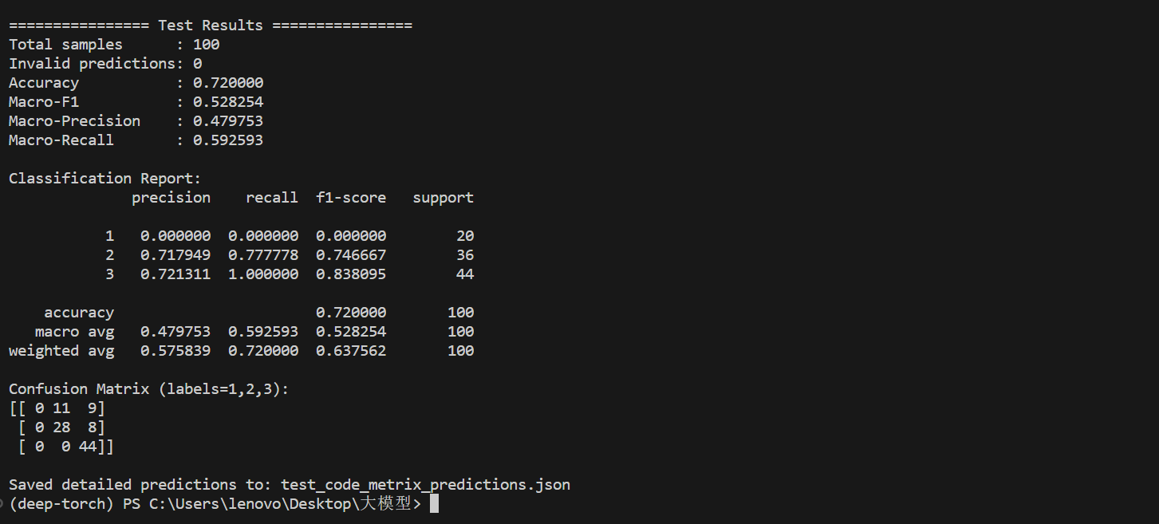

We also tried train the matrix_code, the accuracy was improved to 72%,Macro-F1 52.8%.
But the biggest problem is there actually is no prediction of label 1.
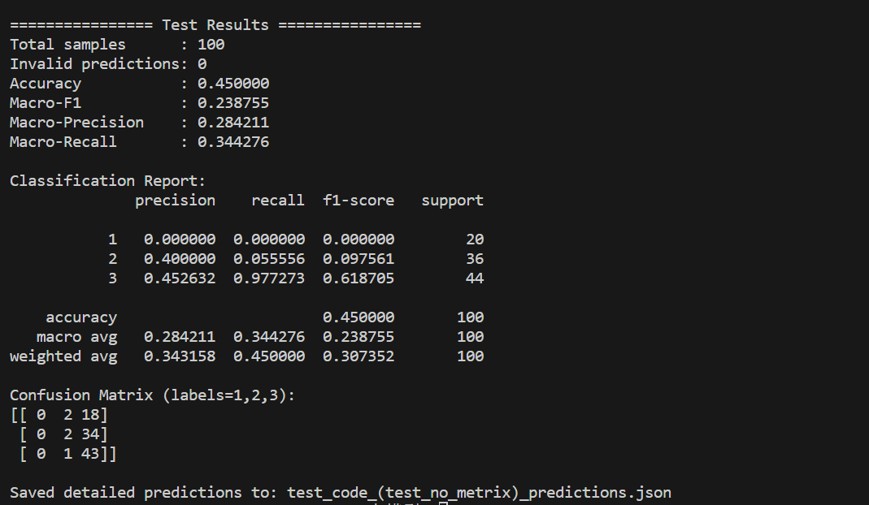

If we train it with code_metrix, but test only with code, the result is extremely bad. It almost focused on label 3. So we don’t recommend such measure.

